Hierarchical DNA Methylation model

Stan Model Fit Results

4/10/2020

Overview:

First, revisiting the TCGA priors

Description of the Stan fit data

Distribution of parameters

Some example genes

Clustering, PCA

Distance-based analysis?

Revisiting the TCGA priors

Good news?

The TCGA prior fits were wrong – I was fitting the variance values, when what I should have been fitting was the sqrt-variance/standard deviation values, because this is what sigma values indicate in the normal distributions within the Stan model.

Not only does this explain why the sigma priors were under-estimates, the distribution of the sigma “estimates” from the TCGA data closely resembles the sigma posteriors from the Stan fits using non-informative priors. Just a qualitative observation to support using these priors.

Therefore, all of the TCGA priors were re-evaluated with fits based on the sqrt-variance distributions. This was done using both inv-gamma and gamma fits, each was close enough to the fit but had some difference. Below are figures of these fits:

Priors: TCGA Distributions and Prior Fit Overlays







The 50-sites sample doc is shared as a separate file,

50sites_TCGApriors_invgamma.docx = inverse gamma fit priors

50sites_TCGApriors_gamma.docx = gamma fit priors (with normal betaT), highly similar

50sites_nonInformGamma.docx = non-informative gamma(4,8) priors and flat normal priors

50sites_uniform.docx = non-informative uniform(0,100) priors and flat normal priors

* This is the version most similar to the Full Stan Results in the rest of this document

Summary of average n_eff values for each prior set:

(50 sites, 500 warmup, 4000 iter total x 4 chains = 14000 iters evaluated)

|  |  |  |  |  |  |  |  |
| --- | --- | --- | --- | --- | --- | --- | --- |
| Prior Set | Priors? | mu | betaT | sigmaP | sigmaPT | sigmaT | sigmaE |
| TCGA_invgamma | Chosen as best: Invgammas for sigmas + sigmaE, Cauchy for betaT, bimodal for mu | **7193** | **6643** | **2994** | **4957** | **1356** | **2374** |
| TCGA_gamma | Gammas for sigmas + normal BetaT | **7328** | **6849** | 2083 | 3936 | 961 | **2492** |
| nonInformGamma | Gamma(4,8) for all | 6463 | 6547 | 2031 | 3165 | 791 | 941 |
| uniform | Uniform(0,100) all | 4584 | 4598 | 508 | 1692 | 162 | 242 |
| TCGA_invgamma_trace  2 chains x 5000 iter, 500 warm | Invgamma for sigmas  Uniform for sigmaE | 3148 | 3135 | 1439 | 2682 | 432 | 526 |
| TCGA_invgammaTrace2  4x5000, w 500  E=Half-Cauchy | Invgamma with half-cauchy(0,2.5) for sigmaE | 4725 | 4810 | 2061 | 3934 | 688 | 768 |

TCGA_invgamma seems the best overall?

In general, the fits look much better now, the estimates for sigmaP and sigmaT are no longer drastically low. Generally, n_eff ranges from 500 to 7000.

The only possibly issue I see is with betaT, the Cauchy distribution is a bit narrower than the estimates distribution, and a few of the sites look like maybe betaT is underestimated (site 134058, but other sites have betaT as high as 2.5)?

Perhaps a normal distribution would work for betaT though it’s slightly broader

Now that these seem to be working, I think we can settle on these priors….

Just need to decide on:

* betaT: normal or Cauchy distribution fits
* sigmaE should we use inv_gamma(1,1) or stick with uniform(0,100)?
  + This is the only parameter I’m not sure how to empirically estimate… maybe using total variance of data?
* How to deal with sites with low n_eff for any given parameter? Say n_eff for sigmaT is <500, would we want to run more iterations or chains for just that site?

Then we can proceed with running the full data on the cluster

Main updates will be adding Darryl’s new data, TCGA-based informative priors, and reporting n_eff + R_hat values

Description of the Stan fit results

We are looking at fit results are from the previous full run results set #3, (last run from 8/8/17)

This model incorporates the following non-informative priors:

sigma_t ~ uniform(0,100);

sigma_e ~ uniform(0,100);

sigma_p ~ uniform(0,100);

sigma_pt ~ uniform(0,100);

mu ~ normal(0,100000);

betaT ~ normal(0,100000);

Basically uniform priors for the sigmas, very flat normals for mu + betaT

Chain parameters for this model were all defaults except adapt_delta:

Chains=4, iter=2000, warmup=1000, thin=1 (no thinning), control = list(adapt_delta = 0.999)

The fitting script applied the Stan model to each site utilizing parallelization and batch processing. Data stored were 6 measures (mean, p2.5, p25, p50, p75, p97.5) from the posteriors of 6 parameters (mu, betaT, sigmaP, sigmaPT, sigmaT, sigmaE).

* Note: future runs will only store (mean, p50, n_eff, r_hat) for the same 6 parameters.

Will update the findings below when new results are run with best set of priors.

Distribution of Parameters:

Showing distributions of median posterior values for each parameter



Log-sigmas and log-sigma-ratios:



Sigma vs Sigma plots (left: 2D histogram all data; right: contour plots using ~1:10 thinning):



Sigma Values as they vary by Gene Region:



Don’t see much here, but perhaps with informed-priors we will see something, or with applying additional sorting/analysis/refinement

Clustering, PCA:

Note: because log-sigma-ratios are considered a change of basis from the log-sigma values (because logarithm of a ratio is the same as difference in the logarithms of each part of the ratio), we consider from here just the log-sigma values, not the log-ratios

**Clustering**:

Clustering was first performed looking for 4 clusters (idea was, we can find areas with low conservation in normal+tumor, low in normal + high in tumor, high in normal + low in tumor, high in both).

Turns out it doesn’t clearly separate these 4 ‘ideal’ clusters we wanted. 4-cluster data is highly similar to 3-cluster so these are both compared below

*K-means clustering – kmeans(data.frame)*

Left is using 3 clusters, Right is using 4 clusters



Clusters are about the same in 3 vs 4, just with 4-clusters, one of the 3-clusters is broken into 2

*Fuzzy C-means clustering – cmeans(data.frame)*

Not very different from the K-means, but still considered a more reliable method



Similar to k-means, 4-clusters sort of breaks up one of the 3-clusters, a little different though

*GMM cluster?* – 2 slow haven’t gotten results

There may be more we can do with clustering if we can somehow consider all of the sites in a gene together (i.e. cluster based on where the entire group of sites in a gene are distributed?)

* Or just cluster based on the mean values for each gene
  + This will take time due to the time for indexing unless I can speed this up
  + Otherwise will need to use the cluster/parallel processing to process genes, mainly due to the indexing of sites in a gene, so we can lump gene-wise analyses together if this is the case
  + Hopefully can just speed up with regex
* Incorporate mu + betaT, which would provide information about the native methylation state and change in tumors

**PCA:**

The 3 PCA axes were determined to be the following linear combinations (% var explained):

PC1 = 0.380*sigmaP + 0.744*sigmaPT + 0.550*sigmaT (53.6%)

PC2 = 0.842*sigmaP – 0.031*sigmaPT – 0.539*sigmaT (26.3%)

PC3 = 0.384*sigmaP – 0.668*sigmaPT + 0.638*sigmaT (20.1%)

Below are plots of the projections of all sites onto each pair of the 3 components:





Clustering on PCA?

**tSNE**:

[insert tSNE, should be a 2D plot?]

Got tSNE to work in R? Not sure the 2D plot just looked like a big circle (need to re-plot)

The algorithm ran but took about an hour

Also testing a “Spectrum” algorithm – also very slow

Usually I’ve seen tSNE used to sort out RNA-seq data from multiple cell types, which works great if you build the tSNE score from a linear combination of the gene expression, etc

However, our data is 3 dimensions of log-sigma values (can add mu + betaT) across 850K sites, with one value for each site from the fit of all of the patients’ bulk tumor methylation data

So it’s not exactly the same data arrangement as multiple cells’ gene expression (which would be much higher dimensionality, and fewer samples)… still could work with sites as the samples and the 3 log-sigma values as features, it’s just not going to cluster as nicely as tSNE on different cell types

We are also not considering mu or betaT in these clustering analyses, though it could offer additional information? I.e. clustering methylated vs de-methylated regions, we could tie this back to recapitulate differential methylation analyses

* Compare sigmaPT (variance of tumor effect) to betaT (magnitude of tumor effect)
* Any effect of high or low mu (methylated/unmethylated state), also could consider those methylated/unmethylated in the tumor by looking at mu+betaT

Some Example Genes:

Here we will look at a few example genes, below is a list with a short description of each gene

GAPDH = important enzyme in glycolysis, therefore important to normal and cancer

(glycolysis maybe upregulated in some cancers)

APC = adenomatous polyposis coli, oncogene commonly involved in familiar colon cancer

TTN = titin, one of largest genes, only expressed in (cardiac) muscle, not in colon tissue

HLA-A = human leukocyte antigen A, Type 1 MHC immune presentation gene, maybe downregulated in cancer as a means of immune evasion

TP53 = p53, a major tumor suppressor, expect to be regulated in normal, dysregulated in cancer

GAPDH:





APC:





TTN:





HLA-A:





TP53:





TODO:

* add plots for each gene on the PCA/tSNE axes
* table of cluster labels (as % of cluster 1, 2, 3 (4) in genes sites)
* add grand mean of gene to sigma x sigma plots, and add alpha to colored points?
* Anything involving mu/betaT?

CpG-Distance-Based Analysis

Based on the analysis in Darryl’s paper “Epigenetic Conservation Is a Beacon of Function:An Analysis Using Methcon5 Software for Studying Gene Methylation” by Hvitfeldt et al 2020.

One of the analyses in the paper looks at the average conservation (here the conservation score is based on average pairwise distance) in relation to the distance of the CpG site from the 5’-most CpG site in the gene

Below is the figure from Darryl’s paper:

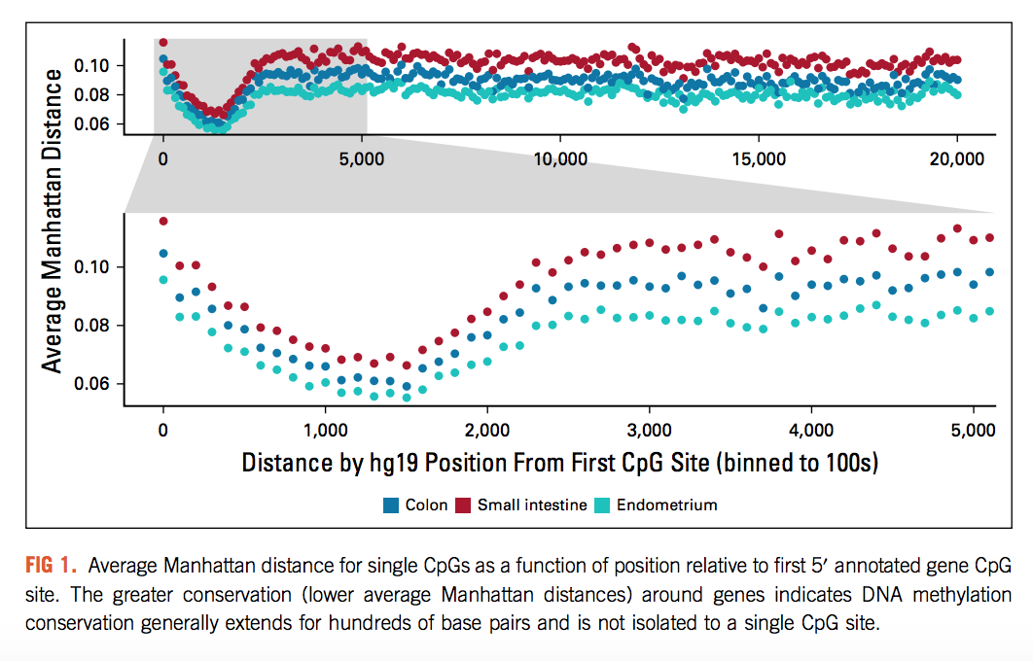

Want to see if our data can replicate this phenomenon

This is my first-pass attempt:



Obstacles run into:

1. The CpG site annotation of the EPIC array indicates the CpG site base position on its chromosome, and also tells if it is on the F or R strand… but this does not exactly specify which direction is 5’ for the gene
   1. Could maybe work around this by looking at the smallest value for the F strands?
   2. This still doesn’t say which way the F strand is facing
   3. Might need to bring in external gene annotation data, something that can define the base range and direction of each gene
   4. Currently just using the lowest CpG site position value as leftmost…. Definitely wrong

Therefore, I still need to complete the analysis here correctly, but it is a good analysis to work on. Recapitulating what Darryl’s paper found would be good, because they found an interesting phenomenon of conservation being very high with a small range of distance near the start of the gene.

Brainstorming more analyses:

General ideas include showing that our results can replicate some common findings of methylation conservation that have been studied before, just a few basic analyses to show our model is valid

Can compare to pairwise-distance type conservation analyses

* + Darryl’s paper shows conservation and gene expression are correlated
  + They also do a nice CpG-distance analysis, and use a bootstrapping method for scoring?
  + Along with some gene ontology

Tried making different algorithms (same priors) to assess run speed, efficiency

Summary of different Stan algorithms – n_eff average values, and run time

(50 sites, 200 warmup 1000 iter total x 4 chains = 3600 iters evaluated)

|  |  |  |  |  |  |  |  |
| --- | --- | --- | --- | --- | --- | --- | --- |
| Algorithm | mu | betaT | sigmaP | sigmaPT | sigmaT | sigmaE | Runtime |
| 1: standard, with if statement | 1711 | 1596 | 691 | 1177 | 311 | 535 | 751.224 33.408 |
| 2: summand, with if statement | 1725 | 1614 | 692 | 1167 | 313 | 548 | 634.700 31.423 |
| 3: tInd in formula for all | 1741 | 1612 | 687 | 1142 | 319 | 544 | 729.396 24.687 |
| 4: summand, tInd in formula | 1718 | 1589 | 699 | 1195 | 313 | 546 | 652.023 12.468 |
| 5: tInd as vector (vs int array)  based on method 4 | 1718 | 1589 | 699 | 1195 | 313 | 546 | 657.184 16.162 |
| 6: using if_else (deprecated), based on method 2 | 1725 | 1614 | 692 | 1167 | 313 | 548 | 681.437 16.185 |
| 7: using ?:, based on method 2/6 | 1725 | 1614 | 692 | 1167 | 313 | 548 | 647.606 31.316 |
| 8: using ?:, separated added terms, based on method 7 | 1718 | 1589 | 699 | 1195 | 313 | 546 | 694.150 50.304 |
| 9: summand1 + summand2, based on method 8 | 1718 | 1589 | 699 | 1195 | 313 | 546 | 752.066 35.627 |
| 10: switching tInd==0 to tInd, based on method 1 | 1707 | 1582 | 689 | 1134 | 319 | 541 | 783.492 65.446 |
| 11: switching tInd==0 to tInd, based on method 2 | 1725 | 1614 | 692 | 1167 | 313 | 548 | 646.889 17.439 |
| 12: switching tInd==0 to !tInd | 1725 | 1614 | 692 | 1167 | 313 | 548 | 646.377 32.155 |
| V: vectorization? Not working! |  |  |  |  |  |  |  |

Notes:

Method 1 is the standard we have been using

Method 2: posteriors/values are highly similar to method 1, exact same on some sites and slightly different on others?

Method 3: Similarly, some sites (the same sites as method 1+2) are exact same, some are slightly different from method 1+2

Method 4: Similar, same sites exactly same, with additional sites exact same as method 3, and rest slightly different

Method 5: Exact same as method 4, maybe slightly slower ~ same speed

Method 6: Exact same as method 2, slightly slower

Method 7: Exact same as method 2, slightly slower

Method 8: Same as method 4/5? (similar to tInd in formula), slower

Method 9: matches method 4, slower

Method 10: works, similar to method 1 with some difference, not sure if slower

Method 11: same as method 2, about as fast

Method 12: same as method 2

Method V: could not get vectorization to work, anything with dot_product is extremely slow

Runoff election:

Method 2, 4, and 7

Again with 50 sites, now 200 warmup, 2000 iter

|  |  |  |  |  |  |  |  |
| --- | --- | --- | --- | --- | --- | --- | --- |
| Algorithm | mu | betaT | sigmaP | sigmaPT | sigmaT | sigmaE | Runtime |
| 2: with (tInd) | 3804 | 3599 | 1537 | 2582 | 685 | 1233 | 1171.790 21.191  1153.134 39.347 |
| 2: with (!tInd) | 3804 | 3599 | 1537 | 2582 | 685 | 1233 | 1148.937 19.130  1160.775 42.550 |
| 4: summand, tInd in formula | 3763 | 3540 | 1533 | 2570 | 700 | 1238 | 1186.107 27.806  1208.674 30.413 |
| 7: using ?:, based on method 2 | 3804 | 3599 | 1537 | 2582 | 685 | 1233 | 1215.274 27.672 |

Method 2: identical to 2!, time is about same

Method 2 ! : things look the same as method 2 (1000 iter), even trace plots

Method 4: highly similar values to method 2 (even closer than with 1000 iter), slightly slower but slightly higher n_eff?

Method 7: exactly same as method 2, slower …. ELIMINATED

Repeating 2,2,4

4 is slower

Method 2 is best, use the (tInd) version because conceptually it is simplest and they are both same speed?